**National Bus Company**

**Team 10**

* Conor Stephens - C23505099
* Abdul Oyebanji - C23375923
* Miracle oshafi - C21348453

**Table Of Content**

* Project Description
* Entity Relationship Diagram
* Relational Model
* Data Definition Language
* Key Reflections

Project Description

This Bus Management System is designed to manage a bus company’s core operations, including branches, staff, drivers, routes, buses, customers, service types, and payment records. Each branch is uniquely identified by a branch number and includes a name, location, and staff details. Bus drivers, identified by unique driver IDs, are associated with branches and have recorded details like name and salary.

The system manages routes, each with a unique route ID and information on departure, arrival, and destination. Buses are uniquely identified by their bus numbers and are linked to a specific driver and route. Each bus also includes details like plate number and type, ensuring that one bus operates under one route and one driver at a time.

Customers can register by providing personal information such as name, date of birth, and customer ID. Customers purchase services categorized by type, with each type having a name and price. All transactions are tracked in the payment table, which records the customer, payment type, and purchase date,

**Roles:**

**Miracle** - Menu navigation ,Tables,Reports,Forms,cover page

**Conor-**Tables,Entity Diagram,Report, Data Definition Language,Menu,Table of content

**Abdul-** Profile Description,Entity Relationship diagram,Relational Model,Reflection,Tables

Entity Relationship Diagram

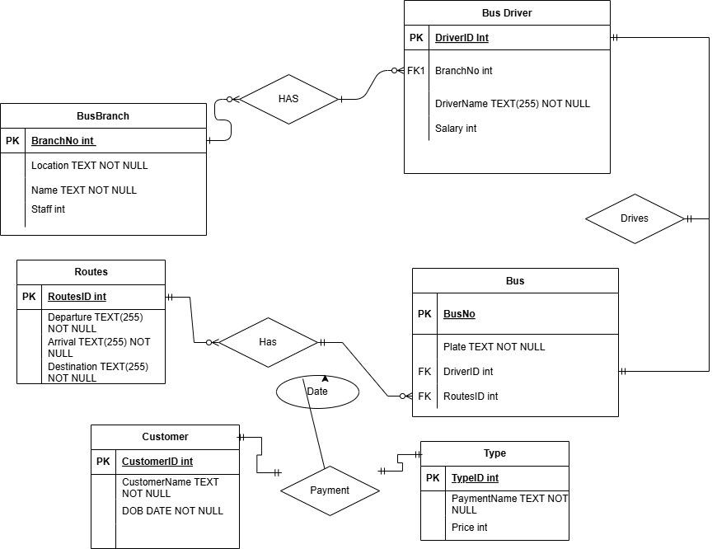

**Relational Model:**

***BusBranch (BranchNo(PK), Location, BranchName, StaffNo)***

***BusDriver(DriverId(Pk) , DriverName, Salary, BranchNo(FK,BranchNo(FK))***

***Routes(RoutesID, Departure, Arrival, Destination)***

***Bus(BusNO, Type, Plate, DriverId(FK), RoutesID(FK),TypeID)***

***Customer(CustomerID, CustomerName, DOB)***

***Type(TypeID, Name, Price)***

***Payement(CustomerID(FK), TypeID(FK), PayDate)***

Data Definition Language

Tables:

**CREATE TABLE BusBranch**(

BranchNo INT PRIMARY KEY,

Location TEXT(255) NOT NULL,

BranchName TEXT(255) NOT NULL,

StaffNo INT

);

**CREATE TABLE BusDriver**(

DriverID INT PRIMARY KEY,

DriverName TEXT(255) NOT NULL,

Salary INT,

BranchNo INT,

FOREIGN KEY(BranchNo) REFERENCES BusBranch(BranchNo)

);

**CREATE TABLE Routes**(

RoutesID INT PRIMARY KEY,

Departure TEXT(255) NOT NULL,

Arrival TEXT(255) NOT NULL,

Destination TEXT(255) NOT NULL

);

**CREATE TABLE Bus**(

BusNO INT PRIMARY KEY,

Plate TEXT NOT NULL,

DriverID INT,

RoutesID INT,

FOREIGN KEY (DriverID) REFERENCES BusDriver(DriverID),

FOREIGN KEY (RoutesID) REFERENCES Routes (RoutesID)

);

**CREATE TABLE Customer**(

CustomerID INT PRIMARY KEY,

CustomerName TEXT NOT NULL,

DOB DATE NOT NULL

);

**CREATE TABLE Payment** (

CustomerID INT,

TypeID INT,

PayDate DATE,

PRIMARY KEY (CustomerID, TypeID, PayDate),

FOREIGN KEY (CustomerID) REFERENCES Customer(CustomerID),

FOREIGN KEY (TypeID) REFERENCES Type(TypeID)

);

**CREATE TABLE Type** (

TypeID INT PRIMARY KEY,

PaymentName TEXT NOT NULL ,

Price INT

);

**Insert Sample Data**

INSERT INTO BusBranch ( BranchNo, Location, Name, Staff )

VALUES (1, 'Ranelegh', 'Ranelagh Station', 10);

INSERT INTO BusBranch ( BranchNo, Location, Name, Staff )

VALUES (2, 'North Road', 'North Hub', 2);

INSERT INTO Bus ( BusNO, Plate, DriverId, RoutesID )

VALUES (501, '12-D-3423', 101, 200);

INSERT INTO Bus ( BusNO, Plate, DriverId, RoutesID )

VALUES (502, '14-D-12223', 100, 201);

INSERT INTO Customer ( CustomerID, CustomerName, DOB )

VALUES (401, 'Lily O Reagan', #1990-06-15#);

INSERT INTO Customer ( CustomerID, CustomerName, DOB )

VALUES (402, 'Jason Park', #1995-09-17#);

INSERT INTO BusDriver ( DriverId, Name, Salary, BranchNo )

VALUES (100, 'Brian O Reilly', 24000, 1);

INSERT INTO BusDriver ( DriverId, Name, Salary, BranchNo )

VALUES (101, 'Ryan Mason', 26000, 2);

INSERT INTO Payment ( CustomerID, TypeID, PayDate )

VALUES (401, 1, #2025-04-14#);

INSERT INTO Payment ( CustomerID, TypeID, PayDate )

VALUES (402, 2, #2025-03-12#);

INSERT INTO Routes ( RoutesID, Departure, Arrival, Destination )

VALUES (200, 'Tallaght', 'Dundrum', 'City Centre');

INSERT INTO Routes ( RoutesID, Departure, Arrival, Destination )

VALUES (201, 'Stephens Green', 'Santry', 'Balally');

INSERT INTO Type ( TypeID, PaymentName, Price )

VALUES (123, 'LeapCard', 3);

INSERT INTO Type ( TypeID, PaymentName, Price )

VALUES (132, 'Cash', 4);

Key Reflections

**Meetings:**

We held around three main meetings throughout the project:

* **Meeting 1 07/04/2025 : We** discussed project requirements and assigned initial roles.
* **Meeting 2 09/04/2025: We** reviewed progress made between our group project showcasing
* **Meeting 3 13/04/2025:** Finalized all parts of the project, including the written sections and diagrams; prepared for submission.

**Strong:**

We divided the technical tasks quickly and we were decisive with the different roles when we were under time pressure. Our understanding of the database structure and how different entities relate to each other improved as we worked through the project.

**Weakness:**

Our biggest weakness was time management. We worked under tight deadlines due to starting tasks later than planned. There was also a lack of organization at times. We were under time pressure.

**What We Would Do Differently:**

In the future, we would start planning and dividing tasks earlier in the project . We would also set up a clear meeting schedule to track progress and responsibilities. Having more frequent check-ins would help keep the project on track and reduce the impact of last minute stress on this project.